Quebec and District Village Hall Association
Agreement for Hire of Venue
Date:
This Agreement is made between (1) The Village Hall named in clause 1.2 acting by its management committee (Quebec Village Hall - Sevenoaks - Registered Charity No. 520874) (“Village Hall”) and (2) The person or organisation named in clause 1.3 (“Hirer”).
AGREED as follows:
1. In consideration of the hire fee described in clause 1.4, the Village Hall agrees to permit the Hirer to use the premises described in clause 1.5 for the purpose described in clause 1.6 for the period(s) described in clause 1.1. The details inserted in sub-clauses 1.1 to 1.7 below and the answers to the question in sub-clause 1.8 are terms of this agreement. This Hire Agreement includes the Standard Conditions of Hire and the Special Conditions of Hire (if any) set out in the Schedule.
1.1 Date(s) required |  | Day(s) |  | Month(s)
Start time |  | Finish time |  | Preparation time
1.2 Hall: Quebec Village Hall
Authorised Representative |  |  | Name: Eleanor Seed  Address: Quebec Village Hall, Front Street, Quebec, Durham, DH7 9DF
Contact telephone number |  |  | 07711 940 384
1.3 Hirer: | Name:
Organisation:

Name of organisation’s
Authorised Representative:
Address:

Contact telephone number

1.4 Hire Fee: | £ per hour |  | Deposit paid £ |  | Balance to pay £
The Hirer shall pay as deposit at 50% of the cost of the booking. The balance of fees are payable on or before the conclusion of the event for which the premises are hired (the deposit having been paid on the signing hereof). This is a non-refundable deposit.
Special Deposit: £ This deposit will be refunded within 14 days of the termination of the period of hire provided that no damage or loss has been caused to the premises and/or contents nor complaints made to the Village Hall about noise or other disturbance during the period of the hiring as a result of the hiring.
1.5 Premises  (please circle) |  | Main Hall  Bar required  Stage |  | Small Meeting Room
1.6 Purpose/description of hiring

1.7 Layout Style
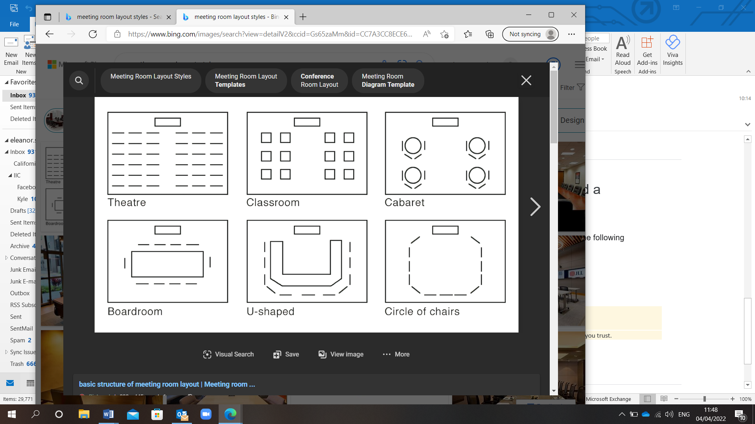
Other… Please state_______________________________________________________
This will be a public/private event?
1.8 Is food (other than biscuits/cakes) being provided at this event?(Please detail)

2. The hirer agrees to notify the Village Hall Committee of any licensable activities taking place at the event and be bound by the terms and conditions of the Premises Licence.
3. The Hirer agrees with the Village Hall Association to be present (by its authorised representative, if appropriate) during the hiring and to comply fully with this Hire Agreement.
4. It is hereby agreed that the Standard Conditions of Hire together with any Special Conditions of Hire shall form part of the terms of this Hiring Agreement unless specifically excluded by agreement in writing between the Village Hall Association and the Hirer.
5. None of the provisions of this Agreement are intended to or will operate to confer any benefit pursuant to the Contracts (Rights of Third Parties) Act 1999 on a person who is not named as a party to this Agreement.
As Witness the hands of the parties hereto:
Signed by the person named at 1.2 above, duly authorised, on behalf of the Village Hall’s Management Committee: | COMMUNITY HALL ASSOCIATION REPRESENTATIVE’S SIGNATURE
Signed by the person named at 1.3 above, duly authorised, on behalf of the organisation named at 1.3 above, where applicable: | HIRER’S SIGNATURE

Room Rates:
Main Hall – Hourly hire £13 (Monday to Thursday)
– Hourly hire £15 (Friday/Saturday/Sunday)
Small Meeting Room – Hourly rate £10
Bar - Available for bookings for private events (Please contact for further details)
Chair Covers – 50p per cover
Chair Bows – 25p each
Bank Details: Quebec & District Village Hall Association
Account Number: 01806628
Sort Code: 30 – 92 - 79

Quebec and District Village Hall Association
Standard Conditions for Hire of Venue
Standard Conditions of Hire
These standard conditions apply to all hiring of the Village Hall. If the Hirer is in any doubt as to the meaning of the following, the Secretary should immediately be consulted.
1. Age
The Hirer, not being a person under 18 years of age, hereby accepts responsibility for being in charge of and on the premises at all times during the session hired and for ensuring that all conditions, under this Agreement, relating to management and supervision of the premises are met.
2. Supervision - The Hirer shall, during the period of the hiring, be responsible for: supervision of the premises, the fabric and the contents; their care, safety from damage however slight or change of any sort; and the behaviour of all persons using the premises whatever their capacity, including proper supervision of car parking arrangements so as to avoid obstruction of the highway and nuisance to neighbours. As directed by the Secretary, the Hirer shall make good or pay for all damage (including accidental damage) to the premises or to the fixtures, fittings or contents and for loss of contents.
2. Use of Premises - The Hirer shall not use the premises for any purpose other than that described in the Hiring Agreement and shall not sub-hire or use the premises or allow the premises to be used for any unlawful purpose or in any unlawful way nor do anything or bring onto the premises anything which may endanger the same or render invalid any insurance policies in respect thereof nor allow the consumption of alcohol thereon without the prior written permission of the Association.
3. Gaming, Betting and Lotteries - The Hirer shall ensure that nothing is done on or in relation to the premises in contravention of the law relating to gaming, betting and lotteries.
4. Licences - The Hirer shall ensure that the Village Hall holds a Performing Rights Society Licence and Phonographic Performance Ltd Licence which permit the use of copyright music in any form e.g. record, compact disc, tapes, radio, television or by performers in person. If other licences are required in respect of any activity in the premises the Hirer should ensure that they hold the relevant licence or the Association holds it.
5. Public Safety Compliance - The Hirer shall comply with all conditions and regulations made in respect of the premises by the Local Authority, the Licensing Authority, the Hall’s Fire Risk Assessment or otherwise, particularly in connection with any event which constitutes regulated entertainment, at which alcohol is sold or provided or which is attended by children.
(a) The Hirer acknowledges that they have received instruction in the following matters:
- The action to be taken in event of fire. This includes calling the Fire Brigade and evacuating the hall.
- The location and use of fire equipment.
- Escape routes and the need to keep them clear.
- Method of operation of escape door fastenings.
- Appreciation of the importance of any fire doors and of closing all fire doors at the time of a fire.
(b) In advance of an entertainment or play the Hirer shall check the following items:
- That all fire exits are unlocked and panic bolts in good working order.
- That all escape routes are free of obstruction and can be safely used.
- That any fire doors are not wedged open.
- That exit signs are illuminated.
- That there are no obvious fire hazards on the premises.
6. Means of Escape
(a) All means of exit from the premises must be kept free from obstruction and immediately available for instant free public exit.
(b) The emergency lighting supply illuminating all exit signs and routes must be turned on during the whole of the time the premises are occupied (if not operated by an automatic mains failure switching device).
7. Outbreaks of Fire - The Fire Brigade shall be called to any outbreak of fire, however slight, and details thereof shall be given to the Secretary of the Association.
8. Health and Hygiene - The Hirer shall, if preparing, serving or selling food, observe all relevant food health and hygiene legislation and regulations. In particular dairy products, vegetables and meat on the premises must be refrigerated and stored in compliance with the Food Temperature Regulations. The premises are not provided with a refrigerator and thermometer.
9. Smoking - The Hirer shall, and shall ensure that the Hirer’s invitees, comply with the prohibition of smoking in public places provisions of the Health Act 2006 and regulations made thereunder. Any person who breaches this provision shall be asked to leave the premises.
10. Electrical Appliance Safety - The Hirer shall ensure that any electrical appliances brought by them to the premises and used there shall be safe, in good working order, and used in a safe manner in accordance with the Electricity at Work Regulations 1989. Where a residual circuit breaker is provided the hirer must make use of it in the interests of public safety.
11. Insurance and Indemnity
(a) The Hirer shall be liable for (i) the cost of repair of any damage (including accidental and malicious damage) done to any part of the premises including the curtilage thereof or the contents of the premises (ii) all claims, losses, damages and costs made against or incurred by the Association, their employees, volunteers, agents or invitees in respect of damage or loss of property or injury to persons arising as a result of the use of the premises (including the storage of equipment) by the Hirer, and (iii) all claims, losses, damages and costs made against or incurred by the management committee, their employees, volunteers, agents or invitees as a result of any nuisance caused to a third party as a result of the use of the premises by the Hirer, and subject to subclause (b), the Hirer shall indemnify and keep indemnified accordingly each member of the Association’s management committee and the employees, volunteers, agents and invitees against such liabilities.
(b) The Association shall take out adequate insurance to insure the liabilities described in sub-clauses (a)(i) above and may, in its discretion and in the case of non-commercial hirers, insure the liabilities described in sub-clauses (a) (ii) and (iii) above. The Association shall claim on its insurance for any liability of the Hirer hereunder but the Hirer shall indemnify and keep indemnified each member of the Association’s management committee and the employees, volunteers, agents and invitees against (a) any insurance excess incurred and (b) the difference between the amount of the liability and the monies received under the insurance policy.
(c) Where the Association does not insure the liabilities described in sub-clauses (a)(ii) and (iii) above, the Hirer shall take out adequate insurance to insure such liability and on demand shall produce the policy and current receipt or other evidence of cover to the Secretary. Failure to produce such policy and evidence of cover will render the hiring void and enable the Secretary to rehire the premises to another hirer. The Association is insured against any claims arising out of its own negligence.
12. Accidents and Dangerous Occurrences - The Hirer must report all accidents involving injury to the public to a member of the management committee as soon as possible and complete the relevant section in the accident book. Any failure of equipment belonging to the Association or brought in by the Hirer must also be reported as soon as possible. Certain types of accident or injury must be reported on a special form to the local authority. The Secretary will give assistance in completing this form. This is in accordance with the Reporting of Injuries, Diseases and Dangerous Occurrences Regulations 1995 (RIDDOR).
13. Explosives and Flammable Substances - The hirer shall ensure that (a) Highly flammable substances are not brought into, or used in any part of the premises and that (b) No internal decorations of a combustible nature (e.g. polystyrene, cotton wool) shall be erected without the consent of the management committee. No decorations are to be put up near light fittings or heaters.
14. Heating - The Hirer shall ensure that no unauthorised heating appliances shall be used on the premises without the consent of the management committee. Portable Liquefied Propane Gas (LPG) heating appliances shall not be used. Central Heating controls shall only be operated by the trustees of the village hall.
15. Drunk and Disorderly Behaviour and Supply of Illegal Drugs - The Hirer shall ensure that in order to avoid disturbing neighbours to the hall and avoid violent or criminal behaviour, care shall be taken to avoid excessive consumption of alcohol. Drunk and disorderly behaviour shall not be permitted either on the premises or in its immediate vicinity. Alcohol shall not be served to any person suspected of being drunk nor to any person suspected of being under the age of 18. Only alcohol purchased on the premises may be consumed. Anyone caught with alcohol not purchased from the hall will be asked to leave immediately, there alcohol will be confiscated and the security deposit paid by the hirer will not be returned.
18. Any person suspected of being drunk, under the influence of drugs or who is behaving in a violent or disorderly way shall be asked to leave the premises. No illegal drugs may be brought onto the premises.
16. Animals - The Hirer shall ensure that no animals (including birds) except assistance dogs are brought into the premises, other than for a special event agreed to by the Association. No animals whatsoever are to enter the kitchen at any time.
17. Compliance with the Children Act 1989 - The Hirer shall ensure that any activities for children under eight years of age comply with the provisions of The Children Act of 1989 and that only fit and proper persons who have passed the appropriate Criminal Records Bureau checks have access to the children. Checks may also apply where children over eight and vulnerable adults are taking part in activities. The Hirer shall provide the management committee with a copy of their CRB check and Child Protection Policy on request.
18. Fly Posting - The Hirer shall not carry out or permit fly posting or any other form of unauthorised advertisements for any event taking place at the premises, and shall indemnify and keep indemnified each member of the management committee accordingly against all actions, claims and proceedings arising from any breach of this condition. Failure to observe this condition may lead to prosecution by the local authority.
19. Sale of Goods - The Hirer shall, if selling goods on the premises, comply with Fair Trading Laws and any code of practice used in connection with such sales. In particular, the Hirer shall ensure that the total prices of all goods and services are prominently displayed, as shall be the organiser’s name and address and that any discounts offered are based only on Manufacturers’ Recommended Retail Prices.
20. Cancellation - If the Hirer wishes to cancel the booking before the date of the event and the Association is unable to conclude a replacement booking, the question of the payment or the repayment of the fee shall be at the discretion of the Association. The Association reserves the right to cancel this hiring by written notice to the Hirer in the event of: (a) the premises being required for use as a Polling Station for a Parliamentary or Local Government election or by-election; (b) the management committee reasonably considering that (i) such hiring will lead to a breach of licensing conditions, if applicable, or other legal or statutory requirements, or (ii) unlawful or unsuitable activities will take place at the premises as a result of this hiring; (c) the premises becoming unfit for the use intended by the Hirer; (d) an emergency requiring use of the premises as a shelter for the victims of flooding, snowstorm, fire, explosion or those at risk of these or similar disasters. In any such case the Hirer shall be entitled to a refund of any deposit already paid, but the Association shall not be liable to the Hirer for any resulting direct or indirect loss or damages whatsoever.
21. End of Hire - The Hirer shall be responsible for leaving the premises and surrounding area in a clean and tidy condition, properly locked and secured unless directed otherwise and any contents temporarily removed from their usual positions properly replaced, otherwise the Association shall be at liberty to make an additional charge.
22. Noise - The Hirer shall ensure that the minimum of noise is made on arrival and departure, particularly late at night and early in the morning. The Hirer shall, if using sound amplification equipment, make use of any noise limitation device provided at the premises and comply with any other licensing condition for the premises.
23. Stored Equipment - The Association accepts no responsibility for any stored equipment or other property brought on to or left at the premises, and all liability for loss or damage is hereby excluded. All equipment and other property (other than stored equipment) must be removed at the end of each hiring or fees will be charged for each day or part of a day at the hire fee per hiring until the same is removed. The Association may, in its discretion in any of the following circumstances, namely (a) in respect of stored equipment, failure by the Hirer either to pay any storage charges due and payable or to remove the same within 7 days after the agreed storage period has ended (b) in respect of any other property brought on to the premises for the purposes of the hiring, failure by the Hirer to remove the same within 7 days after the hiring dispose of any such items by sale or otherwise on such terms and conditions as it thinks fit, and charge the Hirer any costs incurred in storing and selling or otherwise disposing of the same.
24. No Alterations - No alterations or additions may be made to the premises nor may any fixtures be installed or placards, decorations or other articles be attached in any way to any part of the premises without the prior written approval of the Association. Any alteration, fixture or fitting or attachment so approved shall at the discretion of the Association remain in the premises at the end of the hiring. It will become the property of the Association unless removed by the hirer who must make good to the satisfaction of the hall or, if any damage caused to the premises by such removal.
25. Use of Personal Data
Quebec Village Hall records personal data for the purposes of managing the hall, its bookings and finances, running and marketing events at the hall, staff employment and its fundraising activities. Data may be retained for up to 7 years for accounts purposes and for longer where required by the hall’s insurers. The Trustees has a copy of our Data Protection Policy, which deals with rights of access to data held, and is available for inspection on request.
26. No Rights - The Hiring Agreement constitutes permission only to use the premises and confers no tenancy or other right of occupation on the Hirer.
27. Dangerous and unsuitable performances - Performances involving danger to the public or of a sexually explicit nature shall not be given.

CONDITIONS OF HIRE 1-27 ABOVE
Date:
Signature:

